Amazon: Revolutionizing Online Shopping

Anthony Meunier

Consumers and Investors

Introduction

Amazon got its start in 1995 by selling books that were packaged and shipped from a garage in Bellevue, Washington. Now, less than 20 years later the company has grown into one of the largest and most successful online retailers in the world. By providing fast, reliable service and offering millions of products, the company has forged a reputation for itself that can only be topped by… its own desire to once again revolutionize the shopping experience.

Thesis Statement

Our world is evolving and technology is taking over. Businesses have to learn how to adapt in order to cater to what the modern consumer demands. Through forward-thinking and innovative ideas, Amazon has managed to shape what the modern shopping experience has become, and has placed themselves at the forefront of where it could be headed.

1. History of Amazon
2. Beginnings and Expansion
3. Started as an online bookstore with sales up to $20,000/week within first two months
4. 39 warehouses in U.S. as well as 44 international warehouses in 12 countries
5. Popularity and Functions of Website
6. Over 600 million customers visit website annually and importance of customer review system
7. Third-party sellers and marketing via Amazon’s website – account for 40% of sales
8. Offerings and Achievements
9. Products and Digital Services
10. Amazon Prime, free 2 day shipping & access to online movie and book libraries
11. Amazon Kindle and generating sales through digital content
12. Financial Performance
13. Increasing revenue, low profit margin
14. Dedicated growth, trust from investors, use of revenue on expansion
15. What’s in store for the future?
16. Air Drones
17. AmazonFresh (grocery delivery) was testing point for new methods of delivery

2. Will deliver small packages within 30 minutes of ordering

Conclusion

It will be very hard for any competitor to catch up with Amazon in the global race to provide as fast-as-possible service for delivering your online orders. With the support of its investors, Amazon will continue to spend nearly every dollar it makes on adding new shipping centers and developing new products and services. With the announcement of its Air Drone, Amazon once again shows why it’s at the top of the rapidly growing online shopping experience. Amazon pioneered this industry, and they are continuing to revolutionize it – now, and moving forward.

Visual Explanation

This graph indicates how Amazon’s revenue increases year-to-year, yet their net profit is now hardly a tenth of their overall revenue. This is because Amazon, with the permission of their investors, continues to keep expanding and growing. The company uses a large portion of its revenues on new expenditures in order to always be ahead of demand.

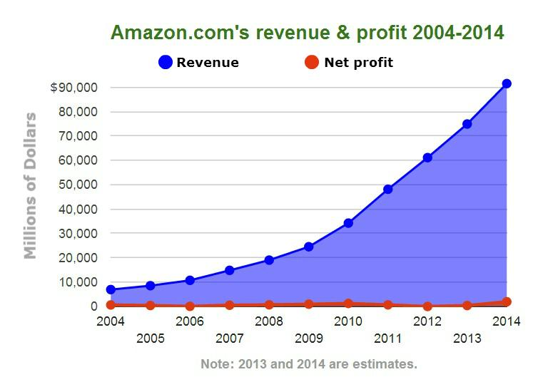

This picture is of an Amazon Air Drone prototype. Within the next few years, Amazon hopes to have a fleet of these air delivery vehicles (capable of delivering up to 5 pounds) at their disposal, and claims that these vehicles will one day be as normal as seeing mail trucks on the road today.

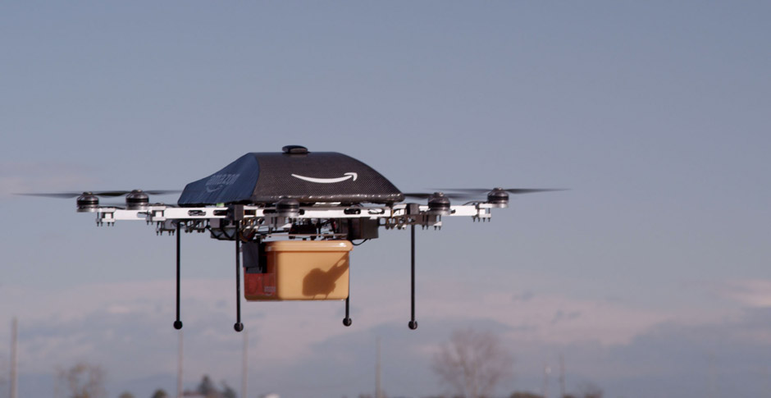

References

Clark, M., & Young, A. (2013). Amazon: nearly 20 years in business and it still doesn’t make money, but investors don’t seem to care. Retrieved from <http://www.ibtimes.com/amazon-nearly-20-years-business-it-still-doesnt-make-money-investors-dont-seem-care-1513368>

Guarini, D. (2013). Amazon reveals it wants to deploy delivery drones. no joke. Retrieved from <http://www.huffingtonpost.com/2013/12/01/amazon-prime-air-delivery-drones_n_4369685.html>

Steinberg, J. (2014). This is how amazon looks historically. Retrieved from <http://seekingalpha.com/article/2116073-this-is-how-amazon-looks-historically>

Stone, B., & Aley, J. (2013). Amazon’s Jeff Bezos doesn’t care about profit margins. Retrieved from <http://www.businessweek.com/articles/2013-01-08/amazons-jeff-bezos-doesnt-care-about-profit-margins>

Webley, K. (2010). A brief history of online shopping. Retrieved from <http://content.time.com/time/business/article/0,8599,2004089,00.html>